The Fayetteville office network system requires an easily modular network. The office will require new technology to stay efficient (Bhat, 2023). A modular system will allow new tech to be quickly swapped out. 50 employees require a modern and fast-paced network capable of uploading & downloading tons of megabits per second (Ashrit, 2020). Fiber, cable, and T1 internet service providers add redundancies in case of outages. The Fayetteville office will continue to run even if one of the three network chains goes down.
The Fayetteville office network system would comprise a wireless system. This is beneficial for fast print jobs to the billboard printers at headquarters in Albany. The WLAN connection allows data to be securely sent over long distances (Ashrit, 2020). WLAN would be used throughout the office to improve the range of data. The Fayetteville office requires data to be secure from hackers and WLAN benefits the organization.
Considerations to inform the systems and resources to meet the organization’s needs and support the business goals and objectives would be energy efficiency, virtualization, and network security. Energy efficiency lowers the organization's energy consumption. This would benefit them by reducing their bills and optimizing the efficiency of their network/devices (Bhat, 2023). Virtualization would help lower organizational costs through the operating systems and software. Network security through firewalls is beneficial for keeping sensitive data private from ISPs, advertisers, and hackers.
The Fayetteville office would benefit from the star or the mesh topology. The star topology protects the organization from a total network failure as each node supports itself (Bhat, 2023). The star topology’s central hub affects network stability, as it must always be operational to avoid a total network failure (Keary, 2024). The star topology meets the Fayetteville office’s needs for a modular system. The downside to this benefit is that the network would be limited by the scalability of the central hub (Keary, 2024). The Fayetteville office could use a star topology, but this LAN topology would hamper the organization's ability to operate efficiently. A central hub failure would cripple the office’s ability to send print jobs for a limited or significant amount of time.
The mesh topology brings the Fayetteville office a secure and redundancy-proof network. The mesh system can survive singular or multiple hardware failures thanks to the node configuration (Bhat, 2023). The crisscrossed node setup brings additional security and performance as each node sends information across different routes to keep network traffic at optimal performance (Keary, 2024). The weaknesses of mesh topology are the cost and complexity.
Mesh topology can be very expensive due to the number of nodes needed (Bhat, 2023). This configuration would increase the organization’s power bill (Keary, 2024). Installing and repairing this topology would be challenging as the crisscrossed node setup makes troubleshooting more difficult (Keary, 2024). The Fayetteville office’s 50 employees would incorporate mesh topology into their daily routine by allowing data speeds to be maintained for live video calls with other locations. Print jobs could be sent promptly and privately maintaining efficiency.
The Fayetteville office would be limited to the internet service providers that support its location. HughesNet is one of the dominant isps in North Carolina. HughesNet would make Satellite internet the main connection with fiber, cable, and T1 redundancies. HughesNet speeds are up to 100 Megabits per second (Charter Communications, 2017) (HughesNet®| Call 844-737-2700 for High-Speed Satellite Internet, 2019). HughesNet claims their connections are low-latency, which is necessary for speedy connections (Charter Communications, 2017) (HughesNet®| Call 844-737-2700 for High-Speed Satellite Internet, 2019).
Satellite Internet is known for having high-latency speeds as the connection has to travel a greater point than other internet types (Schafer, 2019). HughesNet adoption of Wi-Fi 6 allows for secure connections and better upload and download speeds (HughesNet®| Call 844-737-2700 for High-Speed Satellite Internet, 2019). These specific inclusions would impact business goals by altering the desired latency speed, as satellite internet would cause many delays in the organization's efficiency. The Fayetteville office needs speed, HughesNet promises this, but research shows that satellite connections have limitations.
The Fayetteville Office could receive up to 1 gig speed from Spectrum (Charter Communications, 2017). Wi-fi 6 is also used for better connections and lower latency. Secure Wi-Fi is offered but costs, 10 dollars a month (Charter Communications, 2017). This additional fee isn’t a negative as it allows network optimization, data protection, and simultaneous connections for 200 IOT devices (Charter Communications, 2017). The Fayetteville office would benefit from Spectrum’s use of cable connections as it would allow for fast connections. All 50 employees could use Spectrum for interruption-free video calls, thanks to the low latency speed provided by cable internet (Schafer, 2019). Fiber cables being installed means the Fayetteville office could upgrade to a faster connection if necessary.
Hardware and Software solutions for the Fayetteville office would prioritize resolving network issues. Staying up to date through a modular network system allows for easy identification of defective/broken devices. An office of 50 people requires forethought to be put into the technical requirements needed to service them. The hardware must meet the technical benchmarks for the software (Campbell, 2019). Hardware supported by software for at least the next 5 to 7 years is what the organization should look to install. A modular system would allow outdated hardware/software to be removed from the office network without causing a total failure.
The printer solution for the Fayetteville office would require a VPN for printing. The office has remote and mobile employees who use the main network through a VPN. To keep things simple, I would expand VPN usage to the printers for use through the main network. This solution allows remote and mobile employees to access the printer wherever they are through the VPN and make prints for headquarters.
Bandwidth and device fixes for video calls would include prioritizing cable and fiber. These internet connections allow for lower latency connections. This would decrease the amount of video calls dropping or freezing. The network would include a state-of-the-art router capable of upload & download speeds of 1 gigabit. Mesh topology benefits the office network by maintaining regular performance in the crisscross node setup (Keary, 2024). The network’s bandwidth would remain high for continued organizational operation.
The Fayetteville office’s network may encounter slow WI-FI connections. This is due to the office’s size causing wireless connections to be hampered or stopped. To resolve this problem, the connection’s maximum length will be tested, and this data will be written down. After that, the network setup will be modified to resolve the slow connections. The nodes may be damaged by water or a power outage. This damage would cause the network to be partially or completely down. To resolve the problem, each node must be tested to identify the severity of the damage. After that the nodes can be replaced, allowing the network to continue at maximum efficiency. These resolutions to the network allow for efficient identification and testing of errors for the complete restoration and improvement of the network.
Network monitoring would increase the security of the office’s network and lower performance issues. Port scanning increases security by identifying blind spots within the Fayetteville office network (Palo Alto Networks, 2019). This app will help the office network find potential security exploits and update the network to prevent a massive data breach. This process helps develop an effective patch management system. Inventory will be controlled through the main network. This system allows office and remote employees to access inventory through a VPN. They can track prints through the main system by accessing the inventory hub for the office.
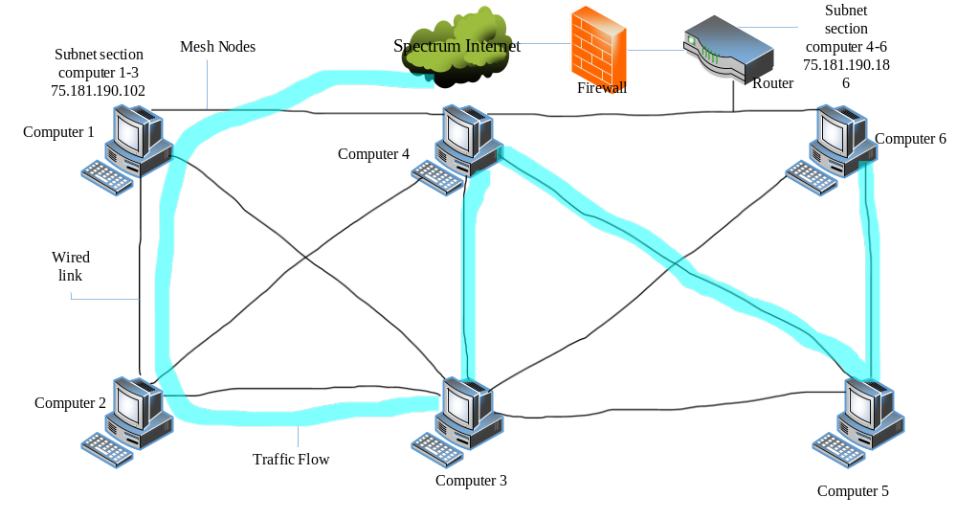

References
Ashrit, L. (2020, April 4). LAN (Local Area Network) - Topology, Types, Applications, Advantages. Electricalfundablog.com. https://electricalfundablog.com/lan-local-area-network-topology-types/
Bhat, S. (2023, May 1). What Is Network Topology? Types, Diagrams, and Benefits. Learn.g2.com. https://learn.g2.com/network-topology
Campbell, A. (2019, August 6). 5 Considerations When Choosing Hardware for your Business. 5 Considerations When Choosing Hardware for Your Business. https://www.sba.gov/blog/5-considerations-when-choosing-hardware-your-business
Charter Communications. (2017). Business Internet, Phone Services and Networking | Spectrum Business. Spectrum.com. https://www.spectrum.com/business
HughesNet®| Call 844-737-2700 for High-speed Satellite Internet. (2019). Hughesnet.com. https://www.hughesnet.com/
Keary, T. (2024, January 10). Network Topology: 6 Network Topologies Explained [Including Diagrams]. Comparitech. https://www.comparitech.com/net-admin/network-topologies-advantages-disadvantages/
Schafer, D. (2019, October 15). Satellite Internet vs. Cable Internet. SatelliteInternet.com. https://www.satelliteinternet.com/resources/satellite-internet-vs-cable-internet/

Palo Alto Networks. (2019). What is a Port Scan? - Palo Alto Networks. Paloaltonetworks.com. https://www.paloaltonetworks.com/cyberpedia/what-is-a-port-scan

